Animal Adaptations Text Set
Alaina Tepper
EDUC Department, Towson State University
EDUC 717: Children’s Literature and Other Materials for Teaching Reading
Dr. David Robinson
March 5, 2021

Animal Adaptations Text Set
Rationale
After speaking with the third-grade team at Georgian Forest Elementary School, we decided a text set regarding animal adaptations would be beneficial to the upcoming science unit on animal survival. The text set would also tie in well with the previous reading unit on informational text about animal adaptations. As such the team and I thought it would fit in well with our students’ background knowledge and add to that knowledge to prepare students for the science unit on how different animals survive better in different environments.
This text set is connected to the Next Generation Science Standard 3-LS4-2: Use evidence to construct an explanation for how the variations in characteristics among individuals of the same species may provide advantages in surviving, finding mates, and reproducing. It also connects to standard 3-LS4-3: Construct an argument with evidence that in a particular habitat some organisms can survive well, some survive less well, and some not survive at all. The texts will be used to research how animal adaptations help animals survive and which adaptations will be most helpful in which habitats. Students will be able to use the resources in this text set as their evidence to support their argument in the assessment as well. This text set and lesson plan is also connected to AASL Standards IV.A.3 and I.C.3. Students will be choosing which habitat will fit the adaptations of the animal they come up with and will chose the right sources to use for research and evidence. As well, students will be choosing the sources needed to research their chosen animal’s adaptations for survival, meeting standard IV.A.3. Students will also be receiving and implementing peer feedback on their animal’s adaptations before finalizing their argument in the summative assessment, meeting standard I.C.3.

Text Set Graphic Organizer
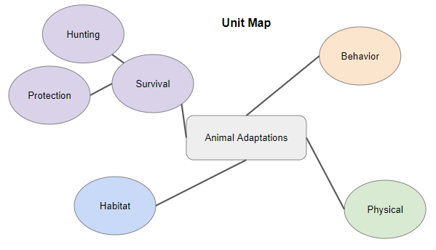

Text Overview Chart
Resource | Annotation | Theme and Features | Ability Level | Genre | Dewey Decimal Number
PebbleGo: Adaptations  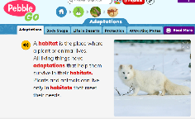  Online resource  Self-Selected Reading | This PebbleGo article has basic information on habitats and a couple of adaptations or reasons for adaptations. It also includes two videos of adaptations in action. | This article is all about how animal’s adaptations help them survive, which is the overall theme of the text set. This resource is unique because it can read aloud to students and includes videos and links to related reading to supplement the article. | This resource can be enjoyed by any level of third grade reader as it has the read aloud function to support lower ability readers while still being challenging enough for average and higher ability readers. | Nonfiction | 591.47
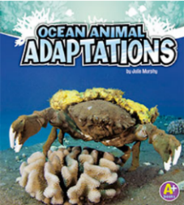  Ocean Animal Adaptations  eBook  Self-Selected Reading | This eBook tells readers all about animals that live in the ocean and the adaptations that help them survive there. The text differentiates between behavior, body covering, and body part adaptations. | This resource will help readers learn what adaptations are helpful for animals that live in the ocean and how those adaptations help them survive. This text includes a read aloud function and the option for readers to read page by page or all at once. It also includes a helpful chart at the end to remind students which animals have which type of adaptation. | With a guided reading level of K, this text is better suited to lower ability third grade readers | Nonfiction | 591.77
Animal Heads: A Song About Animal Adaptations  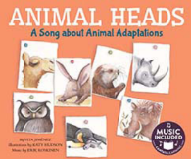  eBook and Song  Read Aloud or Self-Selected Reading | This resource is about different adaptations animals have on their heads, like tusks or whiskers, and how they help the animals in different ways. | This resource shows how the different animal adaptations help them survive, as well as the habitat that the animals live in. This resource is unique because it has a song that goes with it, helping readers remember the information better. | This text has a Lexile number of 460L, making it ideal for lower ability readers in third grade. | Nonfiction | 591.4
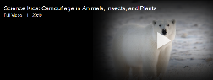  Science Kids: Camouflage in Animals, Insects, and Plants  Video  Self-Selected Reading | This video goes in depth about the adaptation camouflage, sharing the different kinds of camouflage an animal can use. | This video shares how the different types of camouflage keep animals alive in different situations. The video is long but has the option to be broken up into smaller three-to-five-minute chunks of relevant information. | Some of the language in this video is advanced, making it better suited to higher ability readers in third grade. With pre-teaching of vocabulary this video could be suited to all third-grade learners though. | Nonfiction | 591.47
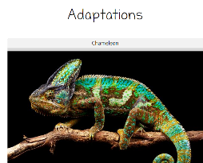  Gale: Adaptations  Website  Self-Selected Reading | This text goes through what adaptations are, why animals might adapt, and examples of physical, behavioral, and other types of adaptations. | This website gives examples of multiple types of adaptations and how they help the animals survive. This website has many accessibility features including read aloud, changing text size, two reading levels to choose from and translation into many languages so students can read the information however they are most comfortable. | This text has two difficulty levels, one suited to lower ability readers and one suited to average ability readers. | Nonfiction | 591.47
Inky the Octopus: Bound for Glory by Erin Guendelsberger  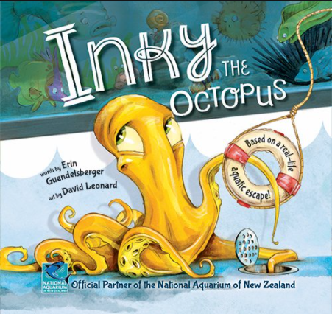  Print Resource  Read Aloud or Self-Selected Reading | This text tells of Inky the octopus’ escape from the aquarium. In his escape he uses or mentions some of his adaptations including his eight arms that can suction and his multiple hearts. | While not directly about Inky’s adaptations, his escape shows how useful his adaptations are in getting to the habitat he feels best in. This text has colorful illustrations that clearly show how Inky is able to use his adaptations to reach his goal. | This book is most suitable for average ability third grade readers but could be read aloud for lower ability readers. | Fiction | 591.77
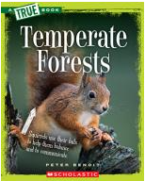  TrueFlix: Temperate Forests  Video and eBook  Self-Selected Reading | This text and video pairing give information about temperate forests, where they can be found, animals that live there, and the adaptations animals there might have. | This resource shows the temperate rainforest habitat, and some of the adaptations you might find of the animals that live there. This TrueFlix resources comes with many extras, including relevant links for students to explore more and an activity to show their understanding of the information. | The text is best suited for higher ability third grade readers, but the “read to me” option can make it more accessible for average ability readers. The video is accessible to all ability levels. | Nonfiction | 591.7
TumbleBooks: Cassy’s Tale  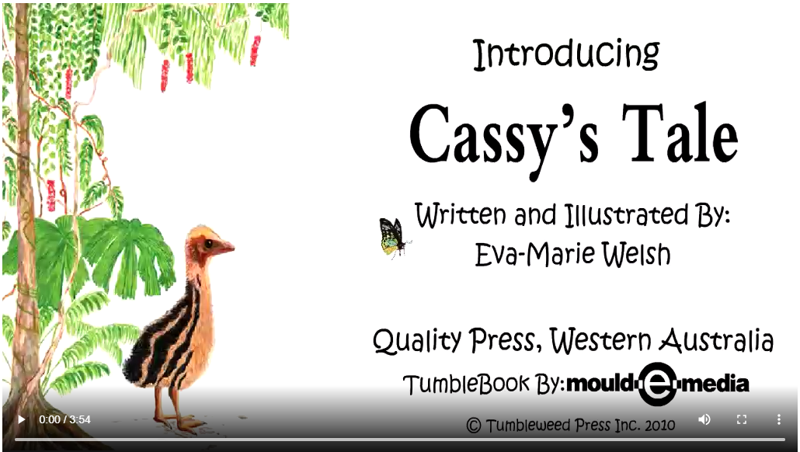  eBook  Self-Selected Reading | This eBook tells of Cassy the baby Cassowary’s first day in the world. She lives in the tropical rainforest with her father, and she learns how her stripes keep her camouflaged, the kinds of food she can find, and how cyclones can damage her habitat. | This text shows how Cassy the baby Cassowary has adaptations that help her survive in the tropical rainforest habitat, and it also shows other animals one might find there. This eBook is read aloud to learners and highlights the words line by line to help readers match the words to the sounds. | This book is best suited for lower ability third grade readers. | Realistic Fiction | 591.47
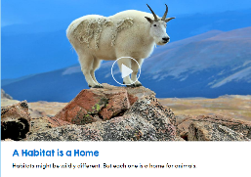  Scholastic Watch and Learn Library: A Habitat is a Home  Video  Self-Selected Reading | This video gives an overview of what a habitat is, and goes into more detail about grassland, mountain, desert, rainforest, ocean, and polar habitats as well as the animals one might find there and how they survive. | Students will need to know what types of habitats there are and what animals thrive in each in order to determine what adaptations bets fit that habitat. This video comes with a read aloud key terms section to help students understand the information and a multiple-choice quiz with a read aloud option for students to show their understanding. The video is available in Spanish as well. | This video is accessible to all third-grade learners but is most suited to average ability learners. | Nonfiction | 591.7
TumbleBooks: Animals in Camouflage  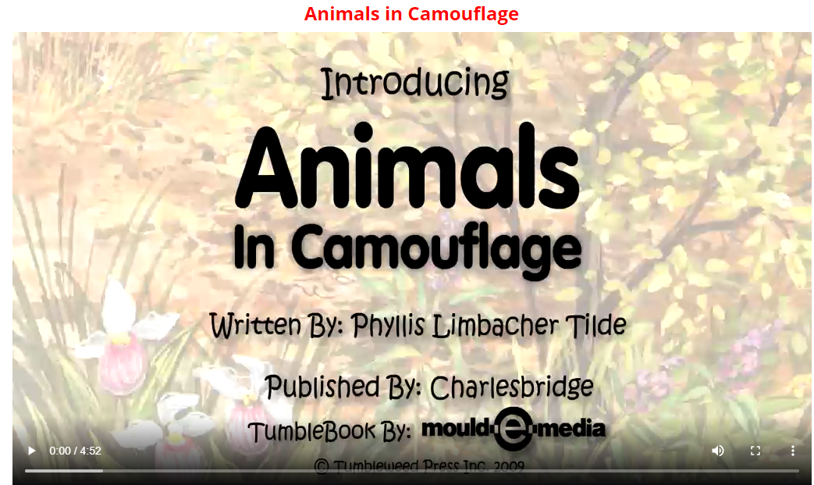  eBook  Self-Selected Reading | This video has a “Who am I?” structure to have students guess and then introduce different animals that use camouflage. It also includes facts about the animals and how the adaptation helps them survive. | This text shows various animals that have the adaptation of camouflage and how that adaptation is helpful to them. This eBook is read aloud to learners and highlights the words line by line to help readers match the words to the sounds. | This book is best suited for lower ability readers but will hold the interest of many readers due to its “who am I?” structure. | Nonfiction | 591.47
Scholastic Watch and Learn Library: Amazing Adaptations  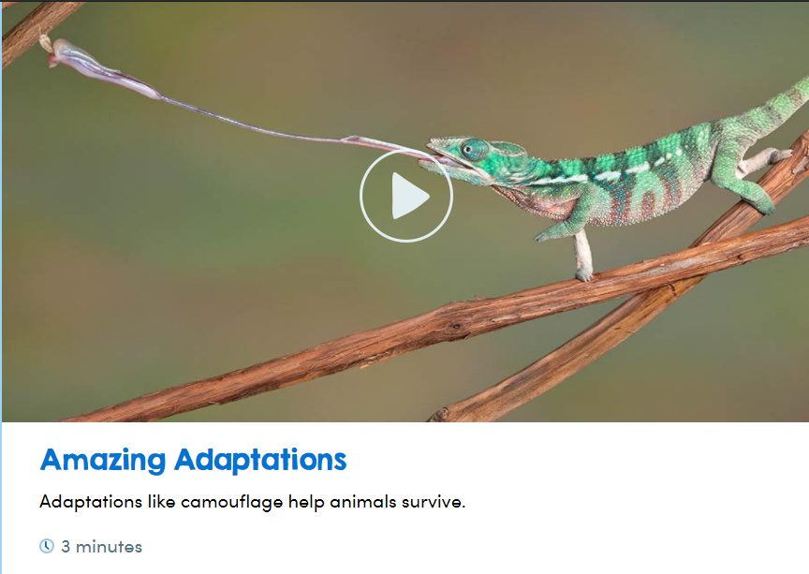  Video  Self-Selected Reading | This video gives a quick overview of some of the uses of adaptations in animals such as hiding/protecting from predators, surviving in the cold, and finding food. It also covers physical adaptations and behavioral adaptations. | This video shows both physical and behavioral adaptations, where most resources focus only on physical adaptations. This video comes with a read aloud key terms section to help students understand the information and a multiple-choice quiz with a read aloud option for students to show their understanding. The video is available in Spanish as well. | This video is accessible to all third-grade learners but is most suited to average ability learners. | Nonfiction | 591.47
Britannica School Elementary: Adaptations  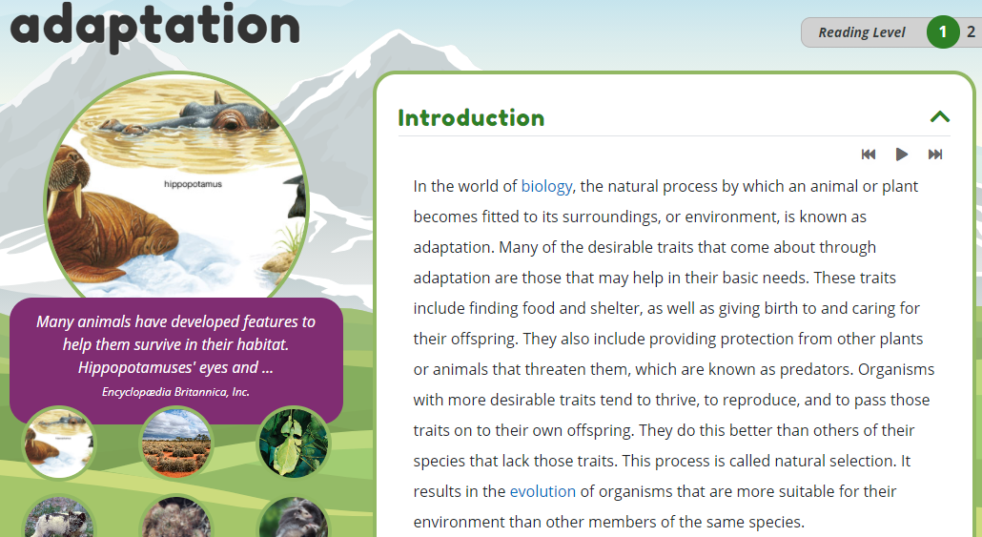  Website  Self-Selected Reading | This website goes through a more thorough explanation of what adaptation means, as well as characteristics of adaptation, ways to adapt and limits to adaptation. | This website shows what adaptation means, how and why certain plants and animals adapt, and why adaptation to one habitat can be harmful to an organism. The website has many helpful images with informative captions to support a reader’s understanding. It also has a read aloud option and a link to related resources on Britannica School. | This website is best suited to higher ability third grade readers but can be accessible for average ability third grade readers with the use of the read aloud button. | Nonfiction | 591.47
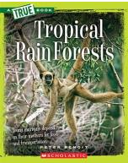  TrueFlix: Tropical Rainforests  Video and eBook  Self-Selected Reading | This text and video pairing give information about tropical rainforests, where they can be found, animals that live there, and the adaptations animals there might have. | This resource shows the tropical rainforest habitat, and some of the adaptations you might find of the animals that live there. This TrueFlix resources comes with many extras, including relevant links for students to explore more and an activity to show their understanding of the information. | The text is best suited for higher ability third grade readers, but the “read to me” option can make it more accessible for average ability readers. The video is accessible to all ability levels. | Nonfiction | 591.7
Study Jams: Biomes  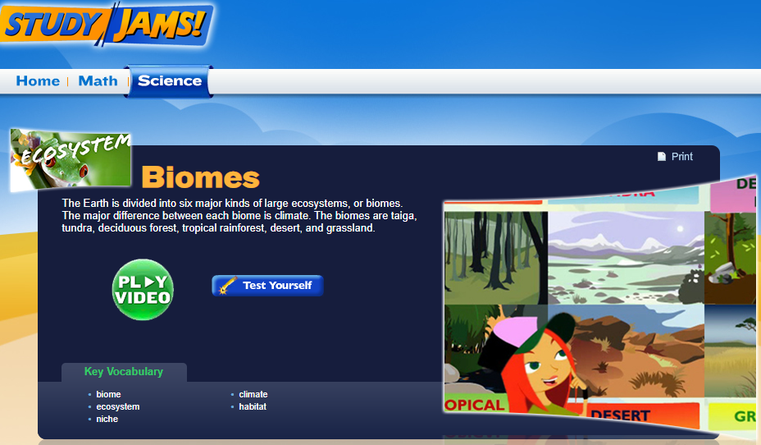  Webpage  Self-Selected Reading | This webpage has a video for students to watch and a quiz to complete after watching. The video gives a quick overview of what a biome is as well as the six different general biomes in the world. The video shows some facts about each biome and what animals are commonly found there. The quiz asks multiple choice questions on the same topic. | This webpage shows the different types of biomes and their features as well as the different animals that live in each. Students can use this to determine which adaptations match best with which biomes. The video and quiz work well together, and the quiz has a check your answers function so that readers can go back and correct anything they might have misunderstood. The page also has key vocabulary and related content listed. | This webpage, specifically the quiz, is best suited for average ability third grade readers or above. | Nonfiction | 591.47
Wild Kratts Creaturepedia  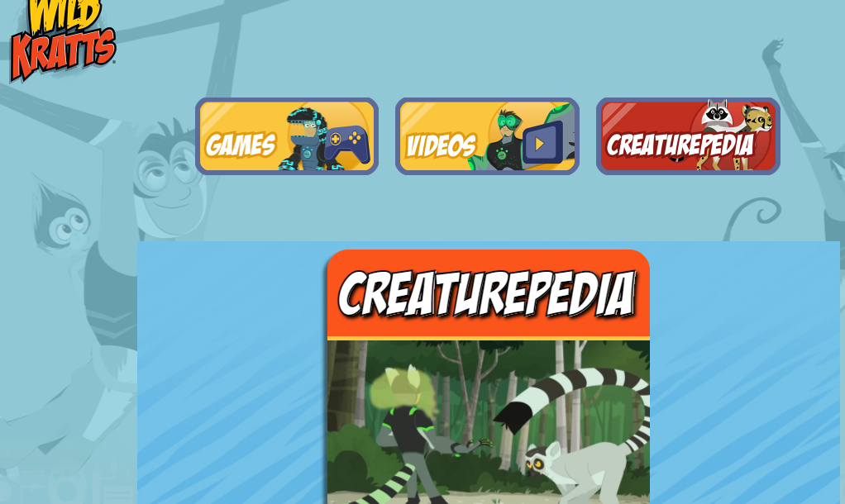  Webpage  Self-Selected Reading | This webpage introduces learners to many different animals and the adaptations they use to survive, such as the ring-tailed lemur’s scent gland. The animals can be explored through animal groups, region they live in, or type of habitat. | This webpage shows a lot of different animal adaptations, as well as where the animals that have them can be found. Each animal profile has multiple photos and videos as well as different sections of information like where the animals live, what they eat, and what their predators are. | This webpage is best suited for third grade readers of average ability or above, while the headings are read aloud the text itself is not. | Nonfiction | 591.47
Animal Adaptations by Louise Spilsbury  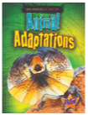  Book  Self-Selected Reading | This book shows unique animal adaptations and general animal facts through text and image. Some of the animals covered include the Leafy Sea Dragon, the Pufferfish, and the Frilled Lizard. | This book shows unique adaptations that are mostly not covered by the other texts in this set. As well, there are many images to better show the adaptations in action as well as activity boxes for learners to extend their understanding. | This text is best suited for higher ability third grade readers but could be read aloud for average ability third grade readers. | Nonfiction | 591.47
I See a Kookaburra!: Discovering Animal Habitats Around the World by Steve Jenkins and Robin Page  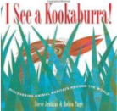  Book  Read Aloud or Self-Selected Reading | This book highlights six habitats and the animals commonly found in each. It also has information on what the animals are doing in their habitats, and general information about each habitat and animal listed at the end. | This book shows animals commonly found in different habitats and the things they do to survive. This will help students see what adaptations work best in different habitats. The text has an I-spy interactive piece throughout to get students really invested in their learning. | This book is best suited for lower ability third grade readers but would be engaging for all third-grade readers due to the interactive elements. | Nonfiction | 591.7
Exploding ants: amazing facts about how animals adapt by Joanne Settel  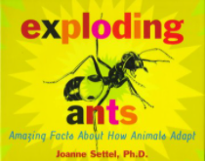  Book  Read aloud or Self-Selected Reading | This book covers some unusual adaptations that help animals survive, ranging from unique camouflage to ants that explode. Many uses for adaptations are also shown, including finding food, defense, and attracting a mate. | This book shows many adaptations not covered in other resources on this list that help animals or groups of animals survive. This book includes information on animals that have adapted to sacrifice themselves for the survival of the group, which no other text covers. There are also many informative pictures to help readers understand the adaptations. | This book is best suited to higher ability third grade readers but could be read aloud to be more suitable for average ability readers. | Nonfiction | 591.5
Natural world: a Visual Compendium of Wonders from Nature by AJ Wood and Mike Jolley  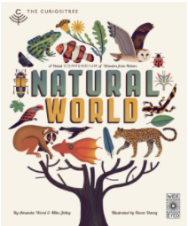  Book  Self-Selected Reading | This book includes many facts, charts, and infographics about animals and plants from all over the world, including how animals are classified, different features of animals, and how they survive. | This text has a lot of information on how animals survive and where they live, showing what adaptations work best in what habitats. This text is comprised of charts and infographics that help readers visualize the information shared. | This text is best suited for average ability third-grade readers and above. | Nonfiction | 508
A Warm Winter Tail by Carrie Pearson  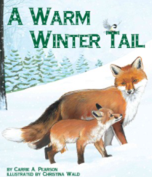  Book  Read Aloud or Self-Selected Reading | This text shares adaptations animals have that help them survive in the winter through the perspective of curious baby animals. The baby animals ask their mothers how humans stay warm in winter and sharing what they do to stay warm in winter. | This text shares animal adaptations from the point of view of the animals themselves. This unique point of view shows how the animals survive and draws readers into the story. As well, the illustrations show the animal adaptations and what humans might look like if they used the same adaptations, showing that different adaptations work better in different situations. | This text is best suited for lower ability third grade readers. | Nonfiction | 591.47

Lesson Plans
Days 1 & 2

Objective: Students will be able to explain in writing and by using drawings to show how an animal’s adaptation allows it to grow and survive.
 | Teacher | Student
Enduring Understanding | LS4.B Natural Selection  Sometimes the differences in characteristics between individuals of the same species provide advantages in surviving, finding mates, and reproducing.
NGSS Connection | Performance Expectation:.3-LS4-2 Use evidence to construct an explanation for how the variations in characteristics among individuals of the same species may provide advantages in surviving, finding mates, and reproducing. [Clarification Statement: Examples of cause and effect relationships could be that plants that have larger thorns than other plants may be less likely to be eaten by predators and animals that have better camouflage coloration than other animals may be more likely to survive and therefore more likely to leave offspring.]
Common Core and additional standard connections: | ELA/Literacy -  RI.3.1 Ask and answer questions to demonstrate understanding of a text, referring explicitly to the text as the basis for the answers. (3-LS4-1)  RI.3.2 Determine the main idea of a text; recount the key details and explain how they support the main idea. (3-LS4-1)  RI.3.3 Describe the relationship between a series of historical events, scientific ideas or concepts, or steps in technical procedures in a text, using language that pertains to time, sequence, and cause/effect. (3-LS4-1)  W.3.1 Write opinion pieces on topics or texts, supporting a point of view with reasons. (3-LS4-1)  W.3.2 Write informative/explanatory texts to examine a topic and convey ideas and information clearly. (3-LS4-1)  W.3.8 Recall information from experiences or gather information from print and digital sources; take brief notes on sources and sort evidence into provided categories. (3-LS4-1.  Mathematics -  MP.2 Reason abstractly and quantitatively. (3-LS4-1)  MP.4 Model with mathematics. (3-LS4-1)  MP.5 Use appropriate tools strategically. (3-LS4-1)  3.MD.B.4 Generate measurement data by measuring lengths using rulers marked with halves and fourths of an inch. Show the data by making a line plot, where the horizontal scale is marked off in appropriate units—whole numbers, halves, or quarters. (3-LS4-1)  WIDA English Language Development Standard 4: Language of Science  - English language learners will communicate information, ideas, and concepts necessary for academic success in the content area of science  AASL Standards:  - IV.A.3 - Making critical choices about information sources to use.
Performance Task: | The performance task is what students do as they explore content within the lesson. Teachers will evaluate student learning through the formative performance task. | Students will create a poster that details the adaptations that helps an animal survive.
Resources: | - butterfly camouflage example (teacher only) | - Animal Adaptations Text Set Resources  - Animal Adaptations Research  - Lesson 3 Day 2 independent follow-up

Recommended Instruction: Day 1: 45 minutes Day 2: 45 minutes
Day 1: (suggested time: 45 minutes)
Engage: (10 Minutes)
1. Show students the butterfly pictures (3 seconds). Then, take it away. (Do not allow them to get up close and only allow a short time for them to view.)
Ask: How many butterflies did you see on the paper?
2. Have students share how many they saw. Now, show them the same picture again for a longer period of time.
Ask:
How many butterflies do you see now?
Was your initial butterfly count wrong? Why or why not?
Does anyone know what this is called? (Camouflage).
Ask the students which butterfly they think would survive in the wild better? (The camouflaged one)

4.Explain that they will be working in groups to conduct animal adaptation research. Put students in groups of no more than four and give students an overview of the text set and have the groups chose an animal to research.
Explore: (35 Minutes)
6. Have the groups complete columns 1 and 2 for their animal before beginning research.

7.Provide students with the text set resources. Each group will read about their chosen animal and fill out column 3 of the Animal Adaptations Research graphic organizer .

Day 2: Suggested Time: 40 minutes

8. Groups will then create a poster that details the adaptations highlighted in their research that helps the animal survive. They can use the draw it features on Nearpod or PearDeck, Kami, Google slides, or create a poster by hand.

The poster should include:
- The animal’s name
- The animal’s habitat
- ‌The animal’s defenses‌ ‌and‌ ‌adaptations‌ ‌that‌ they use to survive

Explain: (20 minutes)
Each group will present their poster.
- Allow the students to meet with their groups for 5 minutes so that they can prepare to present their ideas/poster.
- After 5 minutes, bring the groups back together and have each group present their posters to the class.

Elaborate: (10 Minutes)
- After each group presents, allow students to share knowledge that they didn’t expect or surprised them. As a group, discuss with students why they believe it is important for animals to have these adaptations.
- After the presentations, show students the video Crash Course Kids- Living Things Change.
- After viewing the video, have students share their ideas in the chat about how what they saw in the video matches the newspaper butterflies from the Engage portion of this lesson.

Evaluate: (10 minutes)
Students will complete the formative Lesson 3 Day 2 independent follow-up.

Days 3 & 4

Objective: Students will create a drawing of a new animal/organism that can survive in a particular biome with its adaptations based on research and peer feedback.
 | Teacher | Student
Enduring Understanding | LS4.C: Adaptation  For any particular environment, some kinds of organisms survive well, some survive less well, and some survive not at all
NGSS Connection: | Performance Expectation:.3-LS4-3 Constructs an argument with evidence that in a particular habitat some organisms can survive well, some survive less well, and some not survive at all. [Clarification Statement: Examples of evidence could include the needs and characteristics of the organisms and habitats involved. The organisms and their habitats make up a system in which the parts depend on each other.]  3-5-ETS1-3 Generate and compare multiple possible solutions to a problem based on how well each is likely to meet the criteria and constraints of the problem.
Common Core and additional standard  connections: | ELA/Literacy -  RI.3.1 Ask and answer questions to demonstrate understanding of a text, referring explicitly to the text as the basis for the answers. (3-LS4-1)  RI.3.2 Determine the main idea of a text; recount the key details and explain how they support the main idea. (3-LS4-1)  RI.3.3 Describe the relationship between a series of historical events, scientific ideas or concepts, or steps in technical procedures in a text, using language that pertains to time, sequence, and cause/effect. (3-LS4-1)  W.3.2 Write informative/explanatory texts to examine a topic and convey ideas and information clearly. (3-LS4-1)  W.3.8 Recall information from experiences or gather information from print and digital sources; take brief notes on sources and sort evidence into provided categories. (3-LS4-1)  WIDA English Language Development Standard 4: Language of Science  - English language learners will communicate information, ideas, and concepts necessary for academic success in the content area of science  AASL Standards:  - IV.A.3 - Making critical choices about information sources to use.  - I.C.3 - Acting on feedback to improve
Performance Task: | The performance task is what students do as they explore content within the lesson. Teachers will evaluate student learning through the summative performance task. | Students will create an animal that has been discovered in the Temperate Deciduous Forest biome. Students will then have to decide which biome this animal would survive best in if it was moved and why based on research and peer feedback.
Resources: | - Rubric | - Animal Adaptations Text Set Resources  - My Adapted Animal  - Feedback Sheet  - My Adapted Animal Rubric

Recommended Instruction: Day 3: 45 minutes Day 4: 45 minutes
Day 3: (suggested time: 45 minutes)
Engage (suggested time 10 minutes):
1. Begin by explaining that this week is the culminating lesson in our unit.
2. Explain to students that they will be creating a poster of an organism that will be able to survive in a different biome. They will also create a new animal that has been recently discovered in the Temperate Deciduous Forest biome, but it is not doing well because it does not have the proper adaptations to survive there. Their job will be to decide which biome is best suited to this new animal and why.
3. Give each student the handout My Adapted Animal.
4. Read the storyline with the students and requirements for the project.
Explore (suggested time 30 minutes):
6. Students will independently research using text set materials and create their first draft of the new animal, decide which biome it will be relocated to, and why the new location is best for it. Possible poster options: They can use the draw it features on Nearpod or PearDeck, Kami, Google slides, or create a poster by hand.

Note to teacher: In this section, students should not create their final product. They will be using peer feedback during the Explain portion to complete their final poster.
Day 4: (Suggested Time: 45 minutes)
Explain: Elaborate: (15 minutes)
- Explain to students that today, they will share their newly created animal that has been relocated from the deciduous forest biome to another more suitable biome.
- Have each student share their organism and its special adaptations. The rest of the class should ask questions and give feedback based on the provided Feedback Sheet.

Elaborate: (20 Minutes)

- Once each student has shared, allow a few minutes for the students to make any changes to their animal based on peer feedback.
- Remind the students that they should now make their changes in a different color to allow them to distinguish between their original idea and the ideas from their peers.
- Once all the students have received feedback, have them create a poster including a drawing of the organism and their writing explaining why it will survive best in their chosen biome.

Evaluate: (10 minutes)
- Students will present their final summative posters and writing.

Summative Rubric:
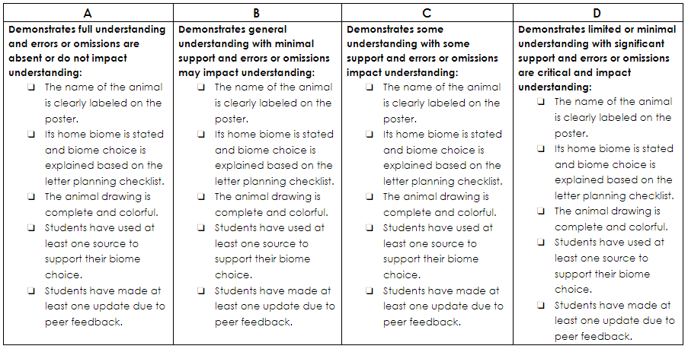

References
Adaptations. (2020). In Gale Elementary Online Collection. Gale, a Cengage Company. https://link.gale.com/apps/doc/JDBGKB276783266/ITKE?u=mcps&sid=ITK E&xid=ae892b3d
Encyclopaedia Britannica. (2021). Adaptation. Retrieved March 16, 2021, from https://school.eb.com/levels/elementary/article/adaptation/352704
Guendelsberger, E. (2020). Inky the octopus: Bound for glory. Naperville, IL: Sourcebooks Jabberwocky.
Jenkins, S., & Page, R. (2016). I see a kookaburra: Discovering animal habitats around the world. Boston, MA: HMH Books for Young Readers.
Jiménez, V. (2017). Animal heads: A song about animal adaptations. Cantata Learning. Retrieved March 16, 2021, from https://www.mycapstonelibrary.com/reader/?isbn=9781632907646
Murphy, J. (2012). Ocean animal adaptations. Mankato, MN: Capstone Press. Retrieved March 16, 2021, from https://www.mycapstonelibrary.com/reader/?isbn=9781429660297
PBS. (2020). Wild kratts creaturepedia. Retrieved March 16, 2021, from https://pbskids.org/wildkratts/creaturepedia/
Pearson, C. A. (2012). A warm winter tail. Mt. Pleasant, SC: Sylvan Dell.
PebbleGo. (2021). Adaptations. Retrieved March 16, 2021, from https://site.pebblego.com/modules/2/categories/2997/articles/2182
Scholastic. (2021). A habitat is a home. Retrieved March 17, 2021, from https://watchandlearn.scholastic.com/videos/animals-and-plants/homes-and-habitats/a- habitat-is-a-home.html
Scholastic. (2021). Amazing adaptations. Retrieved March 16, 2021, from https://watchandlearn.scholastic.com/videos/animals-and-plants/behaviors-and- adaptations/amazing-adaptations.html
Scholastic. (2021). Biomes: Studyjams! science. Retrieved March 16, 2021, from https://studyjams.scholastic.com/studyjams/jams/science/ecosystems/biomes.htm
Scholastic. (2021). Temperate forests. Retrieved March 15, 2021, from
https://sdm-tfx.digital.scholastic.com/p/node-33057/01001910?authCtx=U.600060885
Scholastic. (2021). Tropical rainforests. Retrieved March 15, 2021, from
https://sdm-tfx.digital.scholastic.com/p/node-33057/01001912?authCtx=U.600060885
Settel, J. (1999). Exploding ants: Amazing facts about how animals adapt. New York, NY: Atheneum Books for Young Readers.
Spilsbury, R. (2021). Animal adaptations. Oxford: Raintree.
Tildes, P. L. (2010). Animals in camouflage. Watertown, MA: Charlesbridge. Retrieved March 16, 2021, from https://www.tumblebooklibrary.com/Result.aspx?m=Title&key=Animals%20in%20Cam ouflage
Welsh, E. (2012). Cassy's tale. Mission Beach: Evabooks. Retrieved March 16, 2021, from https://www.tumblebooklibrary.com/Result.aspx?m=Title&key=Cassy%27s%20Tale
Wonderscape, 2017. Science Kids: Camouflage in Animals, Insects, and Plants. [Full Video]. Retrieved March, 16, 2021, from https://www.discoveryeducation.com
Wood, A. J., Jolley, M., & Davey, O. (2016). Natural world: A visual compendium of wonders from nature. London: Wide Eyed Editions.

